**AppDev Co.**

UX DESIGN DOCUMENT

By Vibin Varghese

Email: 20096057@mail.wit.ie

Course: MSc in Enterprise Software Systems

April 20, 2022

Table of Contents

1 UX Document 3

1.1 Overview 3

1.2 Description of the Project 3

2 Goal 4

2.1 Purpose of the website 4

2.2 Scope of the website 4

3 Competitor Analysis 5

3.1 Design features, Functionality and Personal opinion 5

4 User Experience 6

4.1 Personas 6

4.2 Scenarios 6

5 Content Strategy, Navigation Architecture and Visual Design 7

5.1 Content Inventory 7

5.2 Sitemap 7

5.3 Wireframe Sketches 7

5.4 Wire Frames using a UX Tool (Architectural Blueprints) 7

5.5 Mock-Ups using a UX Tool 7

5.6 Screen Capture 7

6 Evaluation & Testing 8

6.1 Usability Heuristics 8

List of Figures

Fig. 1. Internet of Things Architecture 5

UX Document

Overview

This document provides the details of UX Design of “App Developers Company” website. This document covers the details of the project, purpose of the website(goals), scope of the website, detail analysis of competitor websites. Document will also cover the details of end user, audience definition, scenarios, tools used for designing, navigation architecture & visual design and finally the evaluation and testing of the website.

Description of the Project

**Name:** ‘*AppDev’ Company web design project*

**About the company:** *AppDev is a tech company, which develop app for mobile and software application in web interface. It’s a start-up company with limited customer base. Company creates a unique & high-quality application for all generation with simple and user-friendly interface. The company has been running for a year, working solely on social media and app stores.*

The project is to develop a website for this company. As a start-up, company very new to this business, and will need a web designer to design their brand website. The company have developed and deployed lots of mobile apps which is available for the user to download and use. They also have web interface software applications which is sold through enquiry and advertisement. This website needs to handle the user enquiry and show the user about the other mobile applications they have developed. With this the company is looking to grow the business. The website should draw in our target audience – client is looking for something fun and contemporary, yet trendy and sleek at the same time.

Goal

Purpose of the website

Based on Bloom’s Taxonomy Action Verbs, purpose of the website can be set as below.

1. Apply UX design and build a website to show case the apps\services
2. Improve company presence in the market and attracts qualified leads for sales
3. Upcoming projects and informative blogs for the users

Scope of the website

1. ***Apply UX design and build a website to show case the apps\services***

The website for the company required to be unique and the user interaction and expectation is to understand the app, and the services provided. There is certain limitation, since I am using WIX.Com to design and develop the website. The WIX will provide the in-build tools to design, customize and set the color patterns. Also, the limitation of adding different types of pages it allows.

To show case the apps and services, can be made available with the limited scope of WIX tool.

1. ***Improve company presence in the market and attracts qualified leads for sales***

Lead generation is linked directly with the presence of brand in the market. The website must look good, should have good navigation and it must cope with multinational companies. The design tool I use have a limitation to have multi-language support, which can be hosted with region restriction

1. ***Upcoming projects and informative blogs for the users***

The website’s primary purpose is to show case the applications developed by the company in different platform, like mobile and web. Even though the mobile application is published in Google Play Store or an Apple Store, and other website applications are purchased by vast advertisement; An app developer company need to present their product, their vision, customer reviews, top customers, new project, the blogs and the highly skilled team to the world. A website which features all these will help the company to be globally recognized app developer company.

This website also aims to attract qualified leads and allow them to submit their information to the business, who will then follow-up with a sales call. Website is also for informing and educating users; and wants to establish an online presence for themselves to manage their reputation and brand. And provide an online source for their apps to purchase, install and use.

Competitor Analysis

Overview of three similar websites

For the project, I have compared three major app developing companies in Ireland location.

* ***tapadoo.com***

Tapadoo is a mobile app development company based in Dublin. They were founded in 2009 and have a team of 16 employees. They specialize in mobile app development, mobile app modernization, and UX/UI design for clients in healthcare, financial services, and business services industries. They offer a complete app development service; from brainstorming and wireframing, to delivering a pixel perfect finished product. Company takes your app from idea stage, through to development and finally to launching on the app store. They have built apps for the MedTech, Pharmaceuticals, Fintech, Local and National Government, Telecommunications and Wearable Technology. We work with leading brands in Ireland, the UK, US and Canada

* ***squareroot.ie***

Square Root Solutions is a mobile app development company located in Dublin, Ireland. Founded in 2016, they employ between 10 and 49 staff experienced with creating customized mobile applications for a variety of clients. Their expertise covers iOS and Android, game development, VR, IoT, augmented reality, and blockchain. Their Irish and Indian offices work together to ensure all our clients get the most professional and cost-effective experience possible by using Project Management Services of Irish Project Manager and Development Services of Indian Developers.

* ***thecoderspot.ie***

Founded in 2020, The Coder Spot is a mobile app development company. They are headquartered in Dublin, Ireland and have a small team. The company offers mobile app development, web development, application management & support, and custom software development. TheCoderSpot create apps for all platforms, including Android app development, iOS app development, Windows, and more. In addition, we can handle the entire process from developing the idea to creating the designs for user interface and user experience to writing the code to getting the app launched on the Apple app store, Google Play Store, and Windows app store.

Design features

|  |  |  |
| --- | --- | --- |
| **tapadoo.com** | **squareroot.ie** | **thecoderspot.ie** |
| * Mobile view compatible * Simple design for all age group * Dark and white color combination * Scannable webpage with infographic and visuals * A standard is followed in the layout, text and graphic * Website understand the audience | * Not mobile view compatible * More complex design * Navy Blue and white color combination * It’s a readable website, lots of text and with less infographic * Unprofessional layout structure and different text style in some pages * Not clear about the website audience | * Main page is mobile view compatible * Simple design for all age group * Multi color patterns and mainly used white * More infographic and visual website * Graphics, layout, text, and interactive elements works perfect * Very clear understanding of the audience and their requirement |

Functionality

|  |  |  |
| --- | --- | --- |
| **tapadoo.com** | **squareroot.ie** | **thecoderspot.ie** |
| * Simple site navigation and easy to understand * In-site search not available * Have good Blog/news contents * Limited App library, with few reviews * Chat option not provided * Given Search for blogs * Contact and App requirement forms given for the users * No event or release calendar * Social sharing tool for the apps * Only address, but no location map | * Complicated navigation and not easy to find the details * In-site search not available * Blogs are not frequently created and updated * Categorized App library for easy search * Very professional chat option with quick response * No search in general or for in site * Forms to send contact details is given * Event calendar not provided * Social sharing tool for blogs * Not provide any details of location or address | * Graphical Navigation with simple navigation flow * In-site search not available * No Blog/news for the site * No App library, Only the services are mentioned * No options for chat * Searching for content is not available * Contact form is given after filter of service, type of device and budget amount is selected. * Limited details in calendar about new product launch * Social sharing tool for the website * Office address Location is given in home page |

Personal opinion

|  |  |  |
| --- | --- | --- |
| **tapadoo.com** | **squareroot.ie** | **thecoderspot.ie** |
| * The website has given a clear idea about the product and services to the audience * Website is structured well and navigation is simple, so that all generation users can use the website well * Good branding of company and products, by giving the reviews, achievements and short in dept description * Case studies are given in details * Over all a simple and elegant website with good future thoughts. | * This website cannot be scanned, too much of text and less use of infographic. It is very hard to find products and details * Design felt dull, not suitable for a tech company. Website looks more like a software to navigate through * They have tried to brand the website in a way, which annoy the audience by pin down the awards in all pages * Over all, app portfolio page is well structured, but other pages are complicated. | * Infographics is used in most of the areas to get audience attention, rather than the text. * Its is easy for any user to navigate through the site and keep the audience in the website. * A well-designed website, but limited so may functionality which is required for branding and expanding the company. * Over all, designed with high value but lacks the purpose of the website. |

User Experience

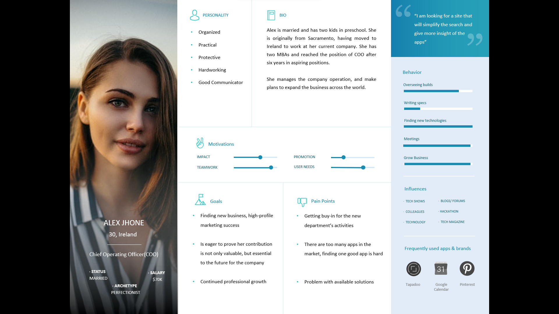Personas

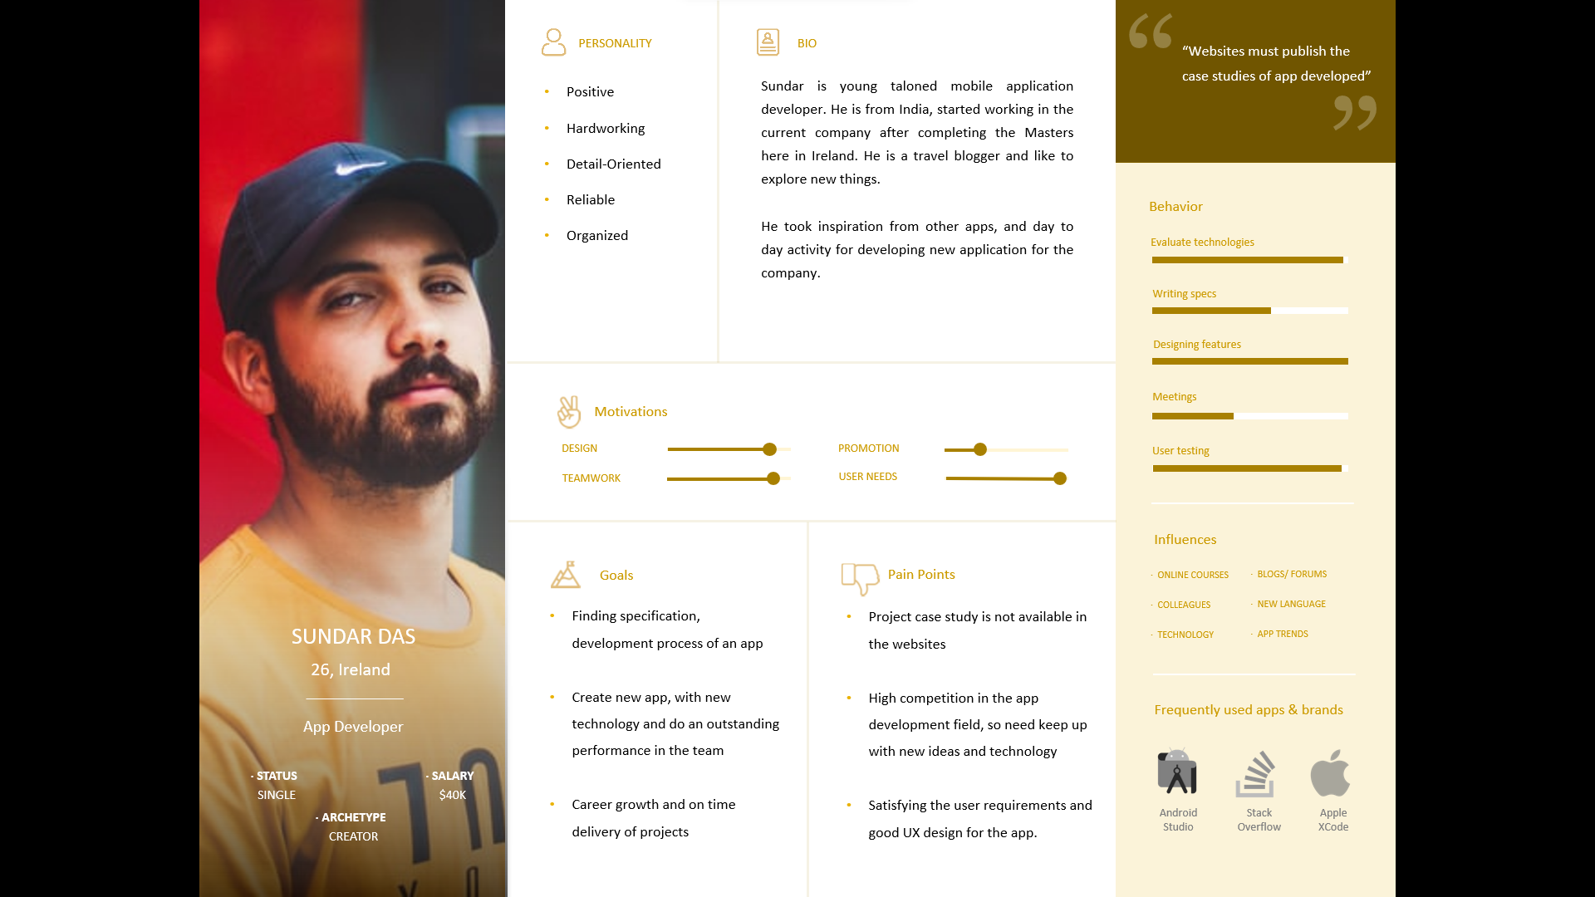

Scenarios

Content Strategy, Navigation Architecture and Visual Design

Content Inventory

Sitemap

Wireframe Sketches

Wire Frames using a UX Tool (Architectural Blueprints)

Mock-Ups using a UX Tool

Screen Capture

Evaluation & Testing

Usability Heuristics